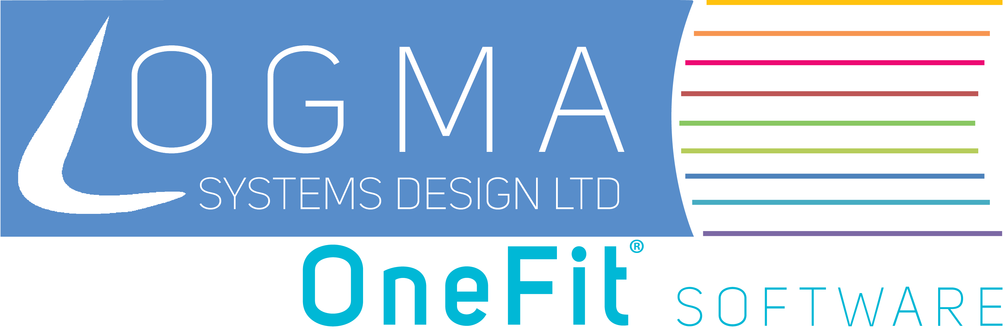

Made Smarter Manufacturing Process Evidence
OneFit ERP supported by Nutrition Group PLC
Purpose. This one-page document demonstrates how OneFit ERP solves manufacturing process challenges by connecting commercial, formulation, production planning and quality workflows.

Business challenge
Manufacturers can lose time when enquiries, formulations, specifications, production plans and corrective actions sit in separate systems or rely on manual updates. This slows response times, increases administration and limits live control of production activity.

How OneFit solves the challenge
- Connects customer enquiries, quotations, formulations and production within one workflow.
- Automatically produces product specifications and allergen information at enquiry stage.
- Transfers an accepted formulation into the live production system without rekeying information.
- Uses live touchscreen production planning to improve control and respond faster to changes.
- Supports corrective and preventative action tracking so actions are controlled and completed.

Published customer evidence
Nutrition Group PLC. The contract supplement manufacturer implemented OneFit as an integrated enterprise solution, combining standard modules with tailored functionality for its manufacturing operation.
Demonstrated outcome | Customer result
Faster enquiries | Customer enquiries could be handled in half the previous time.
Production control | A live production plan improved process control and responsiveness while reducing planning costs.
Business continuity | The move to OneFit was completed without delays to production operations.
Capacity for growth | The customer reported early financial benefit and gained structures, capacity and adaptability to sustain continued growth.

Why this evidence is relevant
This evidence shows OneFit improving a live manufacturing process from first enquiry through formulation and production planning. It reduces manual handling, speeds up operational activity and gives staff better control of the information needed to manufacture and serve customers.
Supporting customer testimonial: Nutrition Group PLC OneFit case study

