The Blue Dragonfly Group

Understanding the BDG Wheel
At the centre of every successful organisation is a simple commercial reality:
A business must generate sustainable profit.
However, profit alone is not the best indicator of the health of a business.
At Blue Dragonfly Group, we believe the clearest indicator of business performance is historical and forecast cash flow.
Cash flow tells the story of where a business has been, how it is performing today, and, more importantly, where it is likely to go in the future. It provides the visibility required for leadership teams to make informed decisions with confidence.
BDG typically works with established SMEs where growth, complexity, or change has outpaced the existing structure of the business.
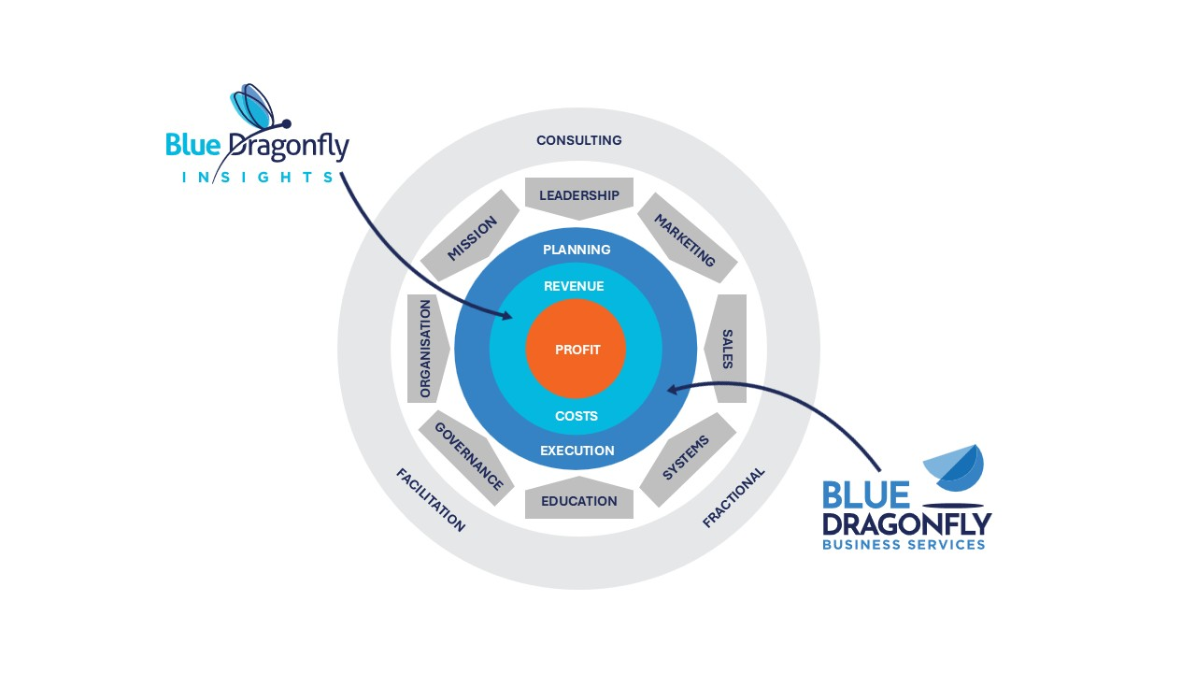

The Commercial Core
At the centre sits profit.
Profit is created through the relationship between two simple but critical components:
- Revenue – the money coming into the business
- Costs – the money leaving the business
The difference between the two determines the profitability of the organisation.
Blue Dragonfly Insights supports this area of the business by helping organisations:
- understand true financial performance,
- improve visibility of revenue and costs,
- analyse historical performance,
- forecast future cash flow,
- identify commercial pressure points,
- and improve financial decision-making.
This creates the financial clarity required for effective leadership and informed planning.

Planning and Execution
Understanding the numbers alone is not enough.
For revenue to grow sustainably and costs to remain under control, a business must have:
- a clear plan,
- and the ability to execute that plan consistently.
Many businesses know what they should be doing but struggle to turn intention into delivery.
That gap between knowing and doing is where Blue Dragonfly Business Services operates.
Around the commercial core of the business sit the operational and leadership disciplines that drive sustainable performance.

Mission
Every business needs clarity around where it is trying to go.
Mission defines the purpose, direction, and long-term goals of the organisation. It provides the reference point for decision-making and strategic planning.

Leadership
Leadership defines how the business is led, managed, and developed.
Strong leadership creates alignment, accountability, clarity, and momentum across the organisation.

Marketing
Marketing generates awareness, interest, and opportunities.
A clear marketing plan ensures the business consistently creates the right flow of leads into the organisation.

Sales
Sales converts opportunities into revenue.
A business must have a clear and repeatable sales process that allows it to consistently convert leads into profitable customers.

Systems
Businesses require systems and processes that support consistent delivery.
As organisations grow, success can no longer rely on heroic effort alone. Systems create scalability, consistency, control, and efficiency.

Education
Continuous education is essential.
This applies not only to employees, but also to business owners and leadership teams. Organisations must continually develop their skills, knowledge, and capability in order to grow.

Governance
Governance is about maintaining control, accountability, visibility, and effective decision-making.
Strong governance helps leadership teams manage risk while maintaining focus, discipline, and direction.

Organisation
Organisation ensures the right people, roles, responsibilities, and accountability structures are in place to support growth and delivery.
As businesses grow in complexity, organisational clarity becomes increasingly important.

How Blue Dragonfly Group Supports Businesses
Blue Dragonfly Group supports businesses across all areas of the wheel through three core approaches.

Consulting
Blue Dragonfly Group can work with organisations on defined consulting engagements focused on:
- identifying challenges,
- building plans,
- implementing improvements,
- and delivering structured business change.
These engagements are typically focused around specific objectives, projects, or business priorities.

Fractional Support
Our preferred approach is often fractional support.
In this model, Blue Dragonfly Group works with a business on an ongoing basis, typically one or two days per month, helping leadership teams:
- develop plans,
- maintain focus,
- create accountability,
- and ensure consistent execution.
This gives businesses access to experienced commercial leadership without the cost or commitment of full-time senior hires.

Facilitation
Sometimes businesses do not need external leadership or delivery support.
Instead, they need structured facilitation to help teams:
- align around priorities,
- build plans,
- improve communication,
- resolve challenges,
- or make strategic decisions.
Blue Dragonfly Group provides facilitation across a wide range of business areas including leadership, planning, marketing, sales, education, governance, and operational improvement.
The result is a business with clearer direction, stronger control, improved accountability, and greater confidence in its ability to deliver sustainable growth.

