Pendle Doors Case Study

- About –

Pendle Doors Ltd is a sustainable door manufacturer based in Burnley and has been responsible for providing its services from the 1950s. This family-run business has been achieving success due to their spirit of continually seeking improvements in quality, delivery, inventory, purchase and lean savings, supported by sales. Additionally, they boast a versatile client base from industries such as Education, Healthcare, Residential and Leisure industries.

- Problem –

Upon contact with AMRC North West, Pendle Doors requested them with designing and additively manufacturing a jig which would allow them to apply pins to fire doors in an accurate and repeatable way to reduce defective products and comply with current regulations.

- Process/ Outcome –

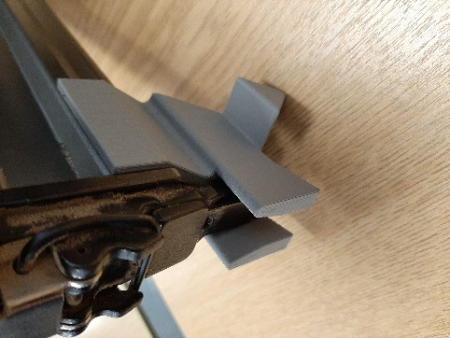
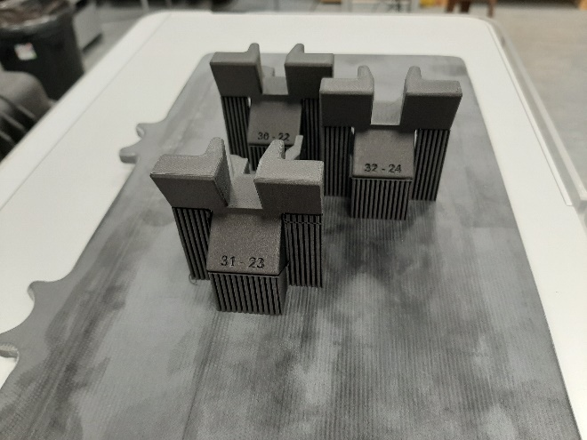
Furthermore, the jig was designed and a prototype was manufactured by the AMRC North West, with Pendle Doors testing the jig to assure their requirements were met. Once Pendle Doors were satisfied with the design, several jigs were produced via additive manufacturing. The use of the jig will lead to productivity gains and reduced waste. Pendle Doors are considering further applications of additive manufacturing within their business.

