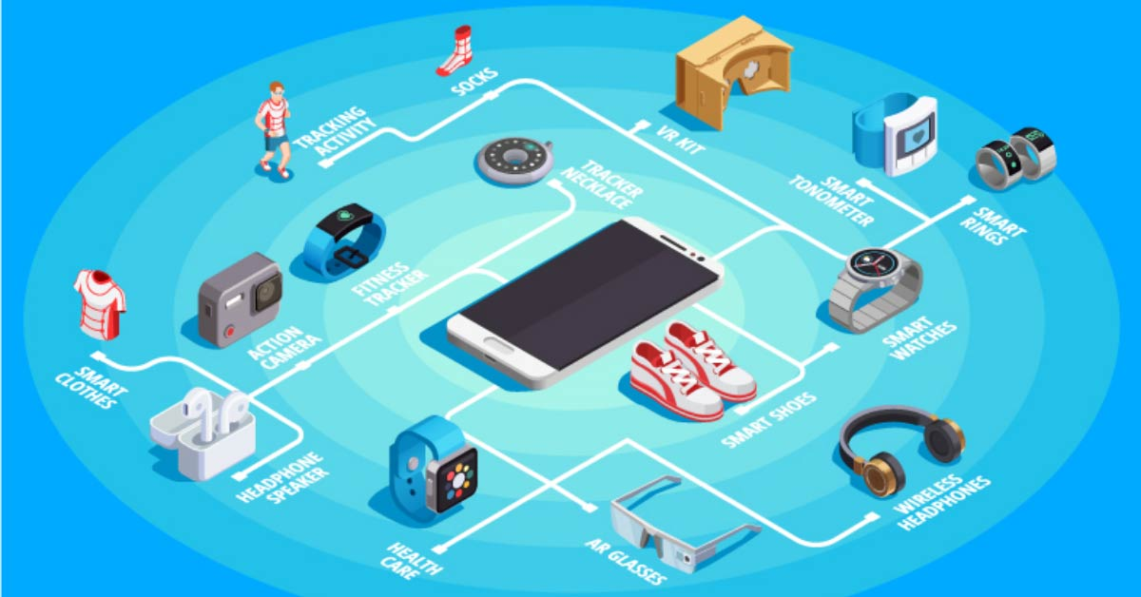

AI-Enhanced IMU Processing for Accurate Positioning & Healthcare Monitoring

smartR AI has developed a proprietary AI-driven algorithm that significantly improves the accuracy of Inertial Measurement Unit (IMU) sensor data, enabling precise positioning and motion tracking from ubiquitous, low-cost IMUs found in smartphones, wearables, and IoT devices. Traditional IMU processing methods (e.g., Extended Kalman Filters) suffer from noise and bias accumulation, leading to rapid drift in dead reckoning applications. Our neural network-based solution reduces positioning errors by over 90%, unlocking new use cases in 3D reconstruction, healthcare monitoring, and industrial sensing.

What is an IMU?
An Inertial Measurement Unit (IMU) is a micro-electromechanical system (MEMS) sensor that measures:

- Acceleration (via accelerometers)
- Rotation (via gyroscopes)
- Some advanced IMUs also include magnetometers (for compass-like orientation).

Where Are IMUs Used?
IMUs are embedded in billions of devices, including:

✅ Smartphones (screen rotation, step counting, AR/VR tracking)
✅ Wearables (fitness trackers, smartwatches, fall detection)
✅ Automotive (airbag deployment, stability control)
✅ Drones & Robotics (flight stabilization, navigation)
✅ Industrial Equipment (vibration monitoring, predictive maintenance)

The Problem with IMUs

Despite their widespread use, IMUs have critical limitations:
- Noise & Bias – Small errors in acceleration/rotation measurements compound over time, leading to drift (e.g., a phone’s step counter may overestimate distance).
- Gravity Interference – Accelerometers detect both motion and gravity, requiring complex filtering to separate them.
- Impact Sensitivity – Sudden movements (e.g., dropping a phone) introduce bias errors, corrupting motion tracking.
Traditional signal processing (e.g., Kalman Filters) struggles with these issues, making IMUs unreliable for high-precision applications.

Business Problem

IMUs are widely available in consumer and industrial devices but are limited by inherent noise and bias, making them unreliable for applications requiring high-precision motion tracking. Current solutions struggle with:

- Drift accumulation in dead reckoning, leading to inaccurate positioning.
- Bias instability in gyroscopes and accelerometers, especially after physical disturbances.
- Limited real-time processing on edge devices due to computational constraints.
These limitations restrict IMUs from being used in mission-critical applications such as:

- 3D reconstruction (requiring precise baseline positioning).
- Healthcare monitoring (e.g., fall detection, medication adherence).
- Industrial automation (e.g., robotic navigation, asset tracking).

smartR AI’s Solution
We partnered with the University of Edinburgh to develop an AI-powered IMU processing algorithm that:
- Dynamically corrects sensor bias using neural networks, reducing drift by 90%.
- Enhances real-time positioning accuracy for 3D reconstruction, providing better camera pose estimation.
- Operates efficiently on edge devices (smartphones, wearables) without cloud dependency.

Key Technical Innovations
- AI-based bias estimation for gyroscopes and accelerometers, improving orientation tracking.
- Sensor fusion optimization to minimize gravity leakage and velocity errors.
- Lightweight neural networks deployable on low-power embedded systems.

Business Applications & Value Proposition

3D Reconstruction & Augmented Reality (AR)

Problem:
- Accurate 3D scanning requires precise device positioning, but IMU drift leads to distorted models.
Solution:
- Our AI-enhanced IMU processing provides stable baseline positioning, improving object size estimation and camera pose initialization.

Market Impact:
- Enables higher-quality mobile 3D scanning for e-commerce, architecture, and gaming.

Healthcare & Elderly Care Monitoring

Problem:
- Dehydration and missed medication are leading causes of falls in nursing homes.
- Existing wearables lack reliable motion tracking for behavioral monitoring.
Solution:
- Smartwatch-based hydration & medication tracking using AI-refined IMU data.
- Real-time alerts for caregivers when patients forget to drink or take pills.

Market Impact:
- Reduces fall-related injuries in elderly care, lowering healthcare costs.
- Patented technology (validated by Opsis Health).
Industrial & IoT Sensing

Problem:
- Industrial sensors (pressure, temperature, current) suffer from noise, requiring expensive calibration.
Solution:
- AI-based sensor fusion extends beyond IMUs to improve all embedded sensor accuracy.
- Edge-compatible processing for real-time analytics in manufacturing and logistics.
Market Impact:
- Reduces sensor costs while improving reliability in automation and predictive maintenance.

Competitive Advantage
Feature | Traditional IMU Processing | smartR AI’s Solution
Accuracy | High drift, unreliable | 90%+ improvement
Bias Correction | Manual calibration required | AI-driven auto-correction
Applications | Limited to basic motion tracking | Healthcare, AR, industrial IoT

Customer Validation
“smartR AI works closely with Opsis. Their deep understanding of AI helps drive product development and has created patents for Opsis.”
– Kevin Grundy, CEO, Opsis Health
Conclusion
smartR AI’s breakthrough in AI-powered IMU processing transforms low-cost sensors into high-precision tracking systems, unlocking new markets in healthcare, AR, and industrial IoT. By reducing drift and enabling edge deployment, we make accurate motion sensing accessible without expensive hardware upgrades.

About smartR AI
We believe that data and AI play a key part in a sustainable world. Our mission is to facilitate and empower organizations to extract real value from their data in an ethical, responsible, and sustainable manner using cutting edge AI technology. We provide solutions that are risk-free, controllable and financially viable for any small or medium-sized enterprise, especially those who are innovators and challengers wishing to shape the future.

We like to think of ourselves as the human face of generative AI, in a world where today’s technology is causing confusion. We've developed proprietary model building blocks to accelerate the development of your project. So, every company can now build its own private AI smarter.

smartR AI augments organizations with AI expertise, driving enterprise-wide implementation, and streamlining workflows. We specialize in safe private AI models that manage risk, while providing high reward. They are specifically trained for clients, enhancing and optimizing productivity, revealing previously unseen insights from their vast data pools. smartR AI improves lives intelligently by empowering workforces with actionable insights.

